Anthony Camacci

INFO 3401-001

Problem Set Two

1. This displays the current directory, problem1

2. cd ~/datasets/activedata then ls -l

3. cd ~ goes to the home directory

mkdir ./problem_set_1 makes a directory called problem_set_1

touch submission.txt makes a text file called submission.txt

cd .. goes back to the previous directory

Pwd would print the home directory

4. cp / config.txt .

cd /

mkdir preferences

cd preferences

cp / prefs.txt

head config.txt

less config.txt

5. I used the command mv /Documents/datafile.csv

I should have used cp /Documents/datafile.csv

I could undo it with rm datafile.csv /Documents/

6. This script prints out a cat

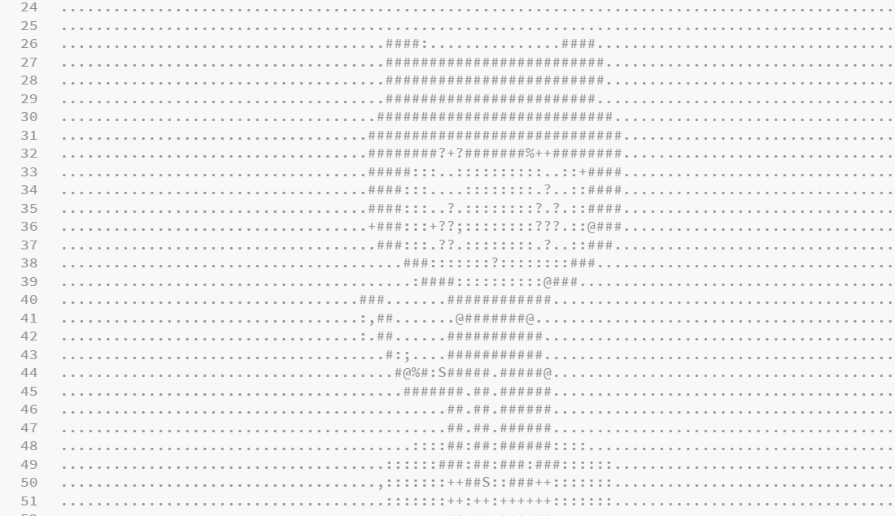

7. Pip install Delorean

It prints the date and time like so: (year, month, day, hour, minute, second and a number with 6 digits)

8. wget <https://finances.worldbank.org/api/views/yu93-ayrw/rows.csv?accessType=DOWNLOAD>

9. grep -c Total rows.csv

10. grep -h Total rows.csv > distilledExpenditures.csv